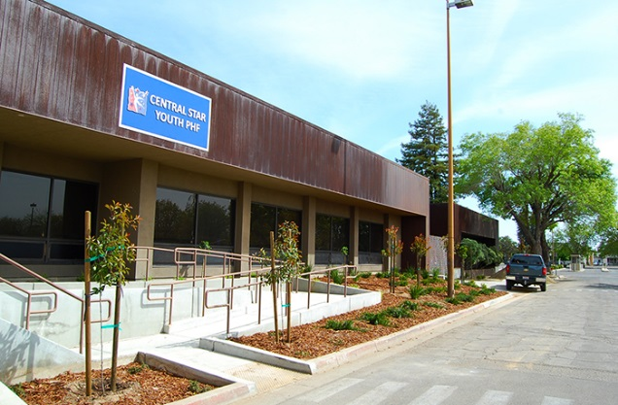

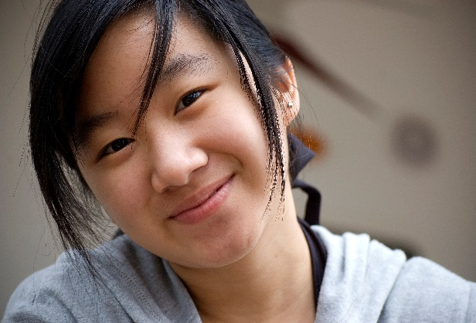Youth

Matters.

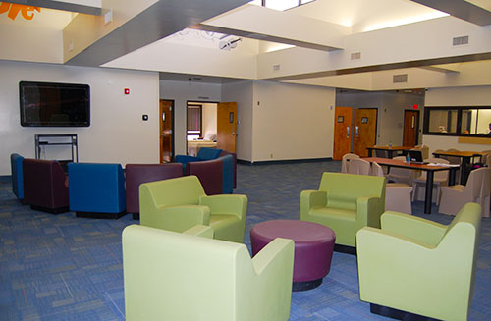

# Central Star Psychiatric Health Facility

4411 E. Kings Canyon Rd. Fresno, CA. 93702 (559) 600-2382

Youth Program Handbook

## 

## WELCOME!

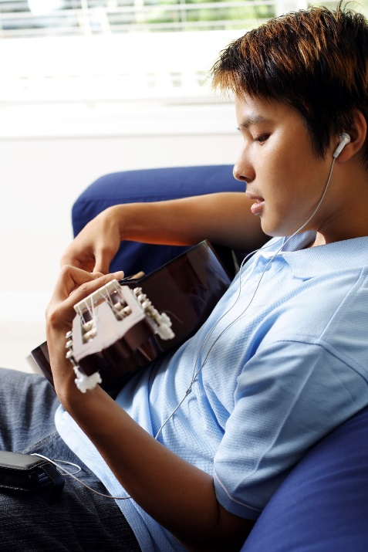We welcome you to our program. We understand it is a hard time for you and we are here to help. Our programs serve many teenagers with great results! Below are examples of what youth tell us upon leaving our programs:

“I was kept safe. The food is good. They helped me sort things out with my family.” – 16 yr. old male

“I didn’t like being locked up. It is strict and very consistent. But that means the clients are treated fairly, which is right. It is a hospital with integrity.” – 17 yr. old female

“The staff are real nice. They treated me with respect. I liked activities and the way they work to help solve problems.” – 14 yr. old female

“My therapist taught me things like how to calm down and think about my own goals before I act. SOS! This will help in life.” – 15 yr. old male

“There are groups for learning about your diagnosis, accepting it, and then learning how to deal with it so it does not mess everything up. People have problems like mine and go on to have a good life. So, I came in darkness but I leave with hope!” – 17 yr. old female

Table of Contents

Our Staff and Program Pg. 3-4

The Daily Schedule Pg. 5-6

Understanding Your Legal Status Pg. 6-7

Your Privacy Rights Pg. 7

Your Rights as a PHF Client Pg. 7

Everyone Follows the Same Rules Pg. 8

Safety is Our Priority (Color System) Pg. 9-10

Preparing for Discharge Pg. 10

## C:\Users\aadams\AppData\Local\Microsoft\Windows\Temporary Internet Files\Content.Outlook\S3NDNXG9\nurse-photo Google images.jpgOUR STAFF AND PROGRAM

The staff who work here have education, experience, training and skills to work with young people who are going through a crisis due to mental health problems. All staff are committed to helping you work toward your discharge. There are Doctors and Nurses trained in medicine who know about physical health, emotions, moods, thinking and behavior. They may have medicines and other treatments to help you with your symptoms, including becoming more in control with yourself.

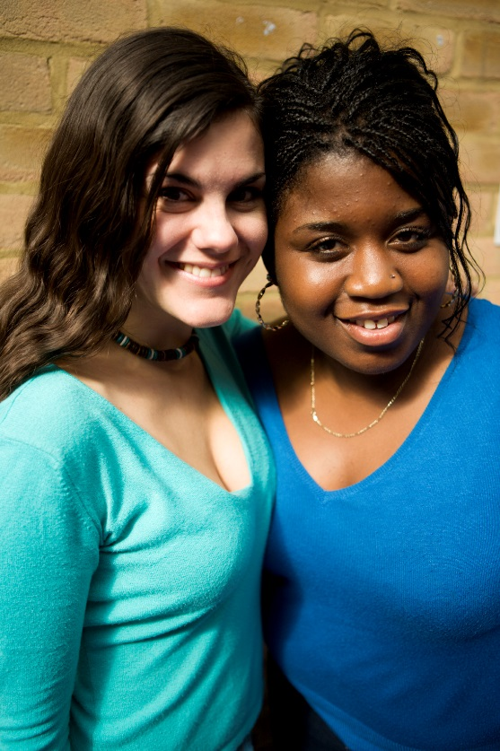 The Admissions Coordinator and Therapists (also called social worker) work with you to better understand what has been going on in your life that brought you to the program.

The Youth Counselors stay close to you throughout each day so that you have the support you need while in the program. They will orient you to your room and the facility so you know your way around and they will help you to meet the other staff and clients. Youth Counselors greet you every morning, and help to see that you can get up and go about your daily business (shower, dress, have breakfast, etc.) and they keep you informed about the schedule of activities and groups. If you have any questions about the program, like what activity is happening next, or what is on the menu for dinner, just ask your Youth Counselor. Youth Counselors are really good people to talk to when you just need to talk and have someone actively listen.

The Rehab Therapist and Aides are in charge of the activities and groups. There is a schedule posted on the unit (ask your Youth Counselors to see this) that shows what activities and groups are happening each day and the time these start and end. A sample of this is on the next page. Also, there is a schedule posted on the unit for visiting hours every day and on the weekend as well as group times with your family members. Your Social Worker can work with you and your family to arrange different visiting times under special circumstances.

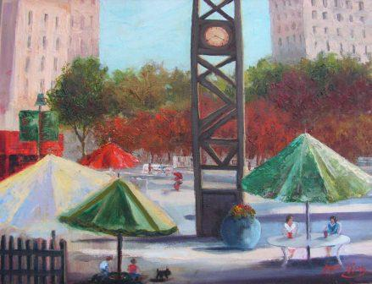 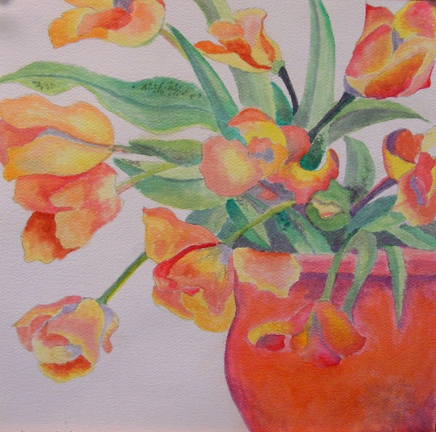 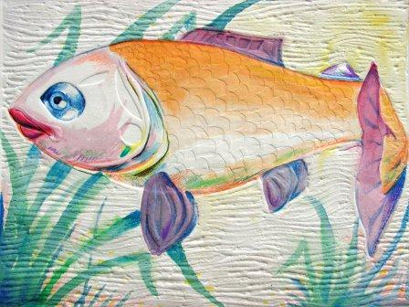

*Art by Fresno County residents from MHSA’s Art Gallery*

|  |  |  |  |  |  |  |  |
| --- | --- | --- | --- | --- | --- | --- | --- |
| **Image result for valentinesGROUP SCHEDULE** [Image result for valentines](https://www.bing.com/images/search?view=detailV2&ccid=ubYOcBCK&id=5651624B3683CD2BD8CFE230EC0230BDE72B0C02&thid=OIP.ubYOcBCKMZ8QnDWsKiNVzAHaGC&mediaurl=http://www.solointhecity.tv/wp-content/uploads/2016/01/vd.jpg&exph=514&expw=630&q=valentines&simid=607986518712780244&selectedIndex=18) | | | | | | | |
| **Word &**  **Skill of the Day** | **SUNDAY**  **Stressed**  **Introducing other people** | **MONDAY**  **Encouraging**  **Giving a compliment** | **TUESDAY**  **Appreciated**  **Asking for help** | **WEDNESDAY**  **Embarrassed**  **Joining in** | **THURSDAY**  **Calm**  **Giving instructions** | **FRIDAY**  **Sleepy**  **Following instructions** | **SATURDAY**  **Happy**  **Apologizing** |
| **8:15- 9** | Community Meeting | Community Meeting | Community Meeting | Community Meeting | Community Meeting | Community Meeting | Community Meeting |
| **9-9:30** | ADL’s  Life moves | ADL’s  Life moves | ADL’s  Life moves | ADL’s  Life moves | ADL’s  Life moves | ADL’s  Life moves | ADL’s  Life moves |
| **9:30-10:15** | Expressive Arts | Expressive Arts | Expressive Arts | Expressive Arts | Expressive Arts | Expressive Arts | Expressive Arts |
| **10:15-10:30** | Snack/Recreational Time | | | | | | |
| **10:30-11:30** | WRAP | WRAP | WRAP | WRAP | WRAP | WRAP | WRAP |
| **11:30-12** | Therapeutic Sports | Therapeutic Sports | Therapeutic Sports | Therapeutic Sports | Therapeutic Sports | Therapeutic Sports | Therapeutic Sports |
| **12-1** | Lunch/ Recreational Time | | | | | | |
| **1-2** | Communication and Self-Regulation skills | Communication and Self-Regulation skills | Communication  Nutrition | Communication and Self-Regulation skills | Communication  Nutrition | Communication and Self-Regulation skills | Communication and Self-Regulation skills |
| **2-3** | Problem Solving Skills | Problem Solving Skills | Problem Solving Skills | Problem Solving Skills | Problem Solving Skills | Problem Solving Skills | Problem Solving Skills |
| **3-3:30** | Snack/Recreational Time | | | | | | |
| **3:30-4** | Therapeutic Sports | Therapeutic Sports | Therapeutic Sports | Therapeutic Sports | Therapeutic Sports | Therapeutic Sports | Therapeutic Sports |
| **4:00-4:30** | Life Skills | Life Skills | Life Skills | Life skills | Life Skills | Life skills | Life skills |
| **4:30-5** | Health Education | Health Education | Health Education | Health Education | Health Education | Health Education | Health Education |
| **5-5:30** | Study Hall | Study Hall | Study Hall | Study Hall | Study Hall | Study Hall | Study Hall |
| **5:30-6:30** | Dinner / Recreational Time | | | | | | |
| **6:30-7** | Therapeutic Sports | Therapeutic Sports | Therapeutic Sports | Therapeutic Sports | Therapeutic Sports | Therapeutic Sports | Therapeutic Sports |
| **7-7:30** | Expressive Arts | Expressive Arts | Expressive Arts | Expressive Arts | Expressive Arts | Expressive Arts | Expressive Arts |
| **7:30-8** | Skill of the day | Skill of the day | Skill of the day | Skill of the day | Skill of the day | Skill of the day | Skill of the day |
| **8-8:30** | Life Moves (after snack) | Life Moves (after snack) | Life Moves (after snack) | Life Moves (after snack) | Life Moves (after snack) | Life Moves (after snack) | Life Moves (after snack) |
| **8:30-9** | Therapeutic Sports / ADL’s | Therapeutic Sports / ADL’s | Therapeutic Sports / ADL’s | Therapeutic Sports / ADL’s | Therapeutic Sports / ADL’s | Therapeutic Sports / ADL’s | Therapeutic Sports / ADL’s |
| **9-9:30** | Community Process Group | Community Process Group | Community Process Group | Community Process Group | Community Process Group | Community Process Group | Community Process Group |
| **9:30-10** | In Room Wind Down | In Room Wind Down | In Room Wind Down | In Room Wind Down | In Room Wind Down | In Room Wind Down | In Room Wind Down |

You can tell a bit about the activities and groups from what they are called in the schedule. A few notes:

* 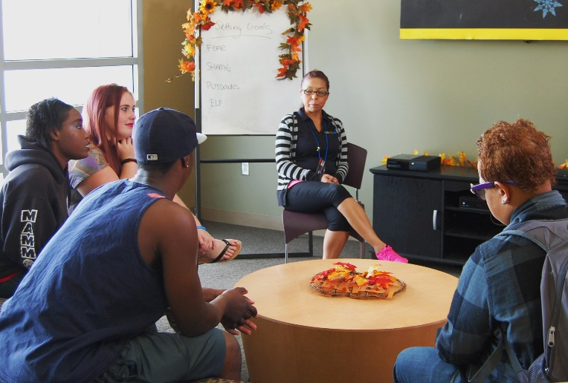“ADLs” are activities of daily living, like getting up in the morning, taking a shower, brushing your teeth, wearing clean clothes, making your bed, etc.
* “Community Meeting” is a time when youth and staff come together to go over the schedule for the day, greet newcomers, say good-bye to those leaving, share what is working for youth, and address issues affecting everybody.
* “Skills” groups include things like anger management, self-calming, communication, conflict resolution and problem-solving.
* “Expressive Arts” are art, drama, and music to channel creative energies for health and well-being.
* “Wellness Group” provides health education, including about thinking, emotions, moods and behavior, and Wellness Recovery Action Planning (WRAP™) which is a method for managing any condition while also enjoying a full life
* We also have daily treatment team meetings where you and your PHF team and anyone else involved in your care will review how you are doing and what needs to happen before you can leave.

Our different kinds of assessments help staff understand your strengths, needs, problems and goals. Please share openly with the staff who are working with you, so they can help get things right with you! Programs like this are here to help you and others be safe, and to find a way forward during crisis. No matter what has gone on, our staff are experts at coming up with solutions for youth.

Understanding Your Legal Status

Some youth are admitted to the program voluntarily. Others are required to stay by law (involuntary) or through their parent’s or Legal Guardian’s authorization. When you are admitted to the program, you will be provided an Advisement of Rights and information about your legal situation. The criteria for involuntary hospitalization are: risk of harm to self and/or risk of harm to other and/or gravely disabled as a result of a mental disorder. The phrase, “gravely disabled” means you are unable to use what is essential to your health and safety, including food, clothing, or shelter even when it’s provided to you. Once you no longer show signs of being a danger to yourself or others or being gravely disabled you will be discharged from the program.

Your Privacy Rights

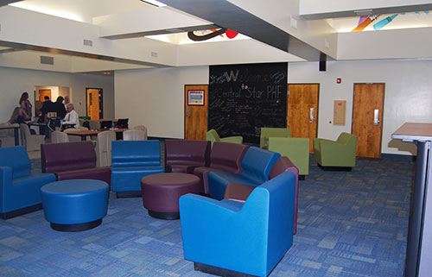 Did you know? It is a violation of privacy laws to share protected health information (PHI) with anyone who is not part of our staff, family members, or someone else involved with your care and treatment. PHI includes names, contact information or something else that would allow you to be identified. Just as we promise to protect your privacy, we expect you to maintain the privacy of the other youth who are also clients in the program, and of their family members.

Your Rights as a PHF Client

When you were admitted to the PHF you were given a copy of “Patients’ Rights.” These are important rules about your rights. There are people you can talk to here at Central Star if you have any questions or concerns or if your rights are not being respected. There are also people outside of the PHF (Fresno County Patients’ Rights advocates) who you can talk with privately. Their phone numbers are posted around the PHF. We can also help you get in touch with the Patients’ Rights advocates.

# Everyone Follows the Same Rules

1. No Passes. There are no passes to temporarily leave for any reason, other than staff-arranged medical or legal appointments.
2. No Storing Food. Family members or other visitors are not allowed to bring food into the facility for you. For safety reasons, staff screen what family or other visitors bring into the facility and remove any food items. You will NOT be allowed to keep any food in the Nurse’s station or in your room. No exceptions.
3. Visitors under 18 years of age are not allowed on the PHF.
4. All visitors must bring a valid ID and sign the visitation log and follow the visitor safety rules. Central Star staff may end a visit at any time if a visitor becomes disruptive, unsafe or does not follow the rules.
5. All hygiene products must be stored in your hygiene box and NO hygiene products are allowed in your room.
6. You will have an opportunity to use the phone every day for a reasonable amount of time. The Youth Counselors will explain how you can ask for phone time and how you can sign up on the client phone list. There is no phone time during groups.
7. Personal Items. During admission your personal belongings will be checked to make sure nothing potentially dangerous (contraband) comes into the facility. For your safety, PHF staff will conduct room searches from time to time to make sure there are not things in your room that can hurt you or someone else.

CONTRABAND = any object that could possibly be used to harm you or others. Weapons, alcohol and drugs are not permitted in the facility. Only medications prescribed by a Central Star doctor are allowed while you are at the PHF. Please give any contraband that you have or might find to staff who will safely store it for you until you are discharged or dispose of it properly.

# Safety is our Priority (COLOR SYSTEM)

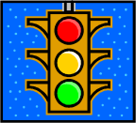 We use a color system to communicate and keep track of your behaviors every day. Your color (**green**, **yellow**, **red**) is an indicator of your safety and participation in the program. Below are examples of what each color level means. Ask a Youth Counselor to go over this information with you.

Here are some examples of why you may be on RED: You have behaved in an unsafe manner, for example, physically fighting (assaulting) peers or staff. Other examples of “Red” behavior are:

* + - Making serious threats to hurt others
    - Self-injury -- cutting, head banging, piercing, poisoning self
    - Serious property destruction that threatens the safety of you and the others around you
    - Sharing medication with a peer or taking another person’s medication
    - AWOL’ing (running away) or attempting to AWOL
    - Sexual or physically intimate contact of any kind, including being in bed together
    - Room visiting without permission, or ‘night crawling’ (leaving your room after bedtime)
    - Encouraging your peers to be aggressive or violent, or interfering in a crisis
    - Bringing contraband onto the unit

Here are some examples of why you may be on YELLOW: You may be isolating yourself from others, refusing to communicate, sleeping all the time, or not doing a sufficient amount of personal self-care and hygiene. Other examples of YELLOW behaviors:

* + - Creating an unsafe environment by refusing to follow safety rules or staff’s directions
    - Being aggressively loud, hurtful and/or disrespectful to others
    - Not attending activities or groups
    - Behaviors that cause significant disruption
    - Taking or using someone else’s property without permission (clothes, books, etc.)

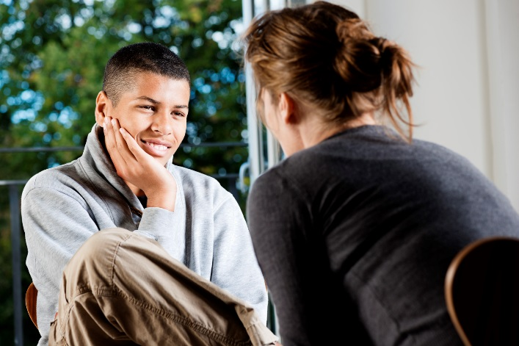

Here are some examples of why you may be on **GREEN**:

* You are **behaving safely and responsibly**, and are **successfully participating** in the program to the best of your ability.

Here are the things we expect you to do every day while you’re staying on the PHF:

1. STAY SAFE!
2. Daily hygiene. We expect you to shower every day and maintain good hygiene habits. You will be provided with all the shower/hygiene products you will need. We also expect you to keep your room neat, your bed made and your clothes clean. The Youth Counselors and Nurses will help you with any problems you have in this area.
3. Tell the Nurse right away about ANY problems with your medications. You can also talk to your Psychiatrist or any of the PHF staff. It is very important that you report any problems with your medications AS SOON AS POSSIBLE.
4. Attend all activities and groups that are offered. We invite you to let the Rehab staff, Social Workers and Youth Counselors know if there are any group topics or activities you would like to suggest.

## PREPARING FOR DISCHARGE

As soon as you are no longer a danger to yourself or others or gravely disabled, you will be discharged from the PHF. We will start working with you and the adults responsible for taking care of you on your discharge plan when you arrive at the PHF. Your Social Worker and Treatment Team will also work with you on what aftercare services and supports will be most helpful to you and/or your family.

We hope your stay with us was helpful and that you’ll let us know what we can do to make our program even better!